Assignment 9
Name : Vaghela Urvashi V.

Module 9 : infrastructure Security an WAN Technologies

Q. 1 ) A Cisco Catalyst switch connects to what should be individual user PCs. Each port has the same port security configuration, configured as follows: interface range gigabit Ethernet 0/1 - 24 switchport mode access switchport port-security switchport port-security mac-address sticky Which of the following answers describe the result of the port security configuration created with these commands? (Choose two)
A. Prevents unknown devices with unknown MAC addresses from sending data through the switch ports.
B. If a user connects a switch to the cable, prevents multiple devices from sending data through the port.
C. Will allow any one device to connect to each port, and will save that device’s MAC address into the startup-config
D. Will allow any one device to connect to each port, but will not save that device’s MAC address into the startup-config
Ans : A) Prevents unknown devices with unknown MAC addresses from sending data through the switch ports.
Reason : Blocks unknown MAC addresses
B) . If a user connects a switch to the cable, prevents multiple devices from sending data through the port.
Reason : Prevents multiple devices on one port.
Q . 2) What is the Administrative Distance of internal EIGRP routes? A. 170 B. 90 C. 20
D. 1 E. 110 F. 120
Ans : B. 90
Q. 3) When a subnet mask is presented in binary, what do the binary 1s represent?
A. The network portion of an associated address
B. The host portion of the subnet mask
C. The number of wildcard bits in the subnet mask
D. The number of wildcard bits in the address
E. The network portion of the subnet mask
F. The host portion of an associated address
Ans :
- The number of wildcard bits in the subnet mas
Q. 4) Which switch would STP choose to become the root bridge in the selection process?
A. 32768: 11-22-33-44-55-66 B. 32768: 22-33-44-55-66-77 C. 32769: 11-22-33-44-55-65 D. 32769: 22-33-44-55-66-78
Ans : A. 32768 : 11-22-33-44-55-66

Q. 5) Which of the following devices is used by the service provider to provide WAN services?
A. Router B. Core router
C. WAN switch D. CSU/DSU
Ans : D.CSU/DSU

Q. 6) Your Cisco IOS router is acting as a DHCP server. Which command will display the addresses that have been handed out to clients on the LAN?
A. show ipdhcp assignments B. show ipdhcp address
C. show ipdhcp conflicts D. show ipdhcp bindings
E. show ipdhcp pool
Ans : D. show ipdhcp bindings

Q. 7 ) Which of the following commands would you use to enable EIGRP only on those interfaces with an IP address from 10.1.1.0 through 10.1.1.63?
A. network 10.1.1.0 0.0.0.63 B. network 10.1.1.0/63
C. router eigrp 10.1.1.0 0.0.0.63 D. network 10.0.0.0 0.0.0.255
Ans :A . network 10.1.1.0 0.0.0.63
Q. 8 ) R3 has a static route configured that points toward the service provider. What command could you use to have R3 advertise an OSPFv3 default route to the internal network, regardless of whether R3 had its default static route?
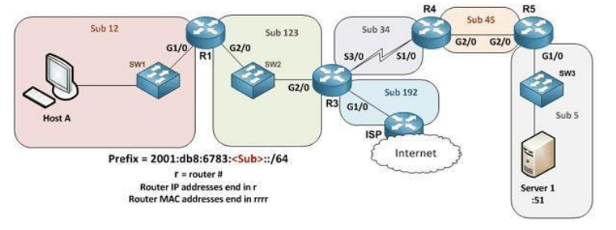

A. The decision to advertise a default route depends on the static route always being present on R3.
B. The default behavior is to redistribute any default IPv6 routes into OSPFv3, so no action is required.
C. Each of the other routers needs a static default route that leads to R3.
D. Use the command default-information originate always in interface mode for G1/0 on R3.
E. Have R3 use the command default-information originate always in OSPFv3 router configuration mode.

Ans : E. Have R3 use the command default-information originate always in OSPFv3 router configuration mode.

Q. 9 ) You are configuring dynamic NAT on your Cisco IOS router. Which command is used to verify the interfaces that are being used as the outside interface and the inside interface?
A. show interfaces B. show ip route
C. show ipnat translations D. show ip interface brief
E. show ip interface F. show ipnat statistics
Ans : F. Show ipnat statistics

Q. 10 ) When using the “show EtherChannel summary “command, what does the “u “flag signify?
A. Waiting to be aggregated B. Suspended
C. In use D. Unsuitable for bundling
Ans :C. In use
Q. 11 ) Which command could you enter to encrypt passwords?
A. enable secret B. username {username} secret {password}
C. service password-encryption D. All of the above
E. None of the above
Ans : D. All of the above

Q. 12 ) You are setting up a Cisco IOS router as a DHCP server. Which command is used to identify the IPv4 addresses that will be in the DHCP pool?
A. network B. dns-server
C. default-router D. ipdhcp excluded-address
E. lease F. ipdhcp pool
G. domain-name
Ans :A. network
Q. 13) Which of the following statements are true regarding the processing of ACLs that have been applied to router interfaces? (Choose two)
A. Inbound ACLs will be processed before the routing table lookup occurs
B. Inbound ACLs will be processed after the routing table lookup has occurred
C. Outbound ACLs will be processed after the routing table lookup has occurred
D. Outbound ACLs will be processed before the routing table lookup occurs
Ans : A. Inbound ACLs will be processed before the routing table lookup occurs
c. . Outbound ACLs will be processed after the routing table lookup has occurred
Q.14 ) Which statements describe neighbor discovery functionality in IPv6? (Choose two)
A. Determines the link layer address of a neighbor
B. Finds neighbor switches on the link
C. Is achieved by using Dynamic Host Configuration Protocol for IPv6, or DHCPv6 with IPv6 multicast
D. Queries for duplicate addresses
Ans :
- Determines the link layer address of a neighbour
D. Queries for duplicate addresses
Q. 15 ) Which IPv6 prefix will the typical enterprise network receive from the service provider?
A. /52 B. /56 C. /64
D. /32 E. /48 F. /60
Ans : E. /48
Q. 16 ) How should be configured a switch so that it could be accessed remotely?
A. Assign a password and privilege level
B. Apply the access control list, or ACL, to the virtual type terminal, or vty, lines
C. Configure a gateway for the switch
D. Generate a certificate
Ans : A. Assign a password and privilege level
Q. 17 ) Refer to the exhibit. A network technician is asked to design a small network with redundancy. The exhibit represents this design, with all hosts configured in the same VLAN. What conclusions can be made about this design?
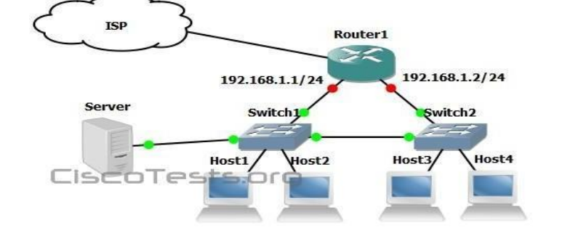

A. This design will function as intended.
B. Spanning-tree will need to be used.
C. The router will not accept the addressing scheme.
D. The connection between switches should be a trunk.
E. The router interfaces must be encapsulated with the 802.1Q protocol.
Ans :
B. Spanning-tree will need to be used.
D. The connection between switches should be a trunk.

